[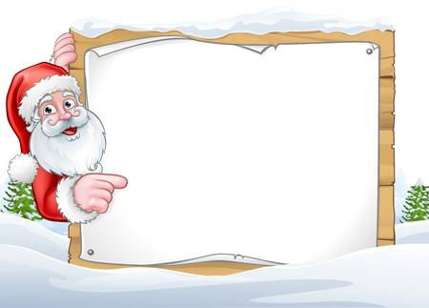](https://previews.123rf.com/images/krisdog/krisdog1711/krisdog171100376/90006962-santa-claus-christmas-sign-background.jpg)

**Thursday 13th December 2018**

**6pm – 8pm**

**Tickets cost £3**

**Available from school office**

**St Oliver Plunkett Primary School**

Invites you to

Supper with Santa