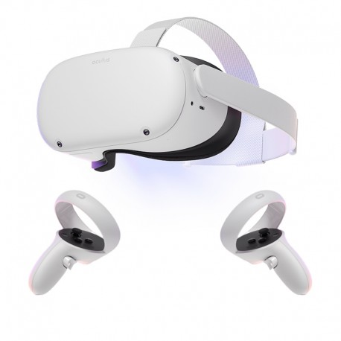
Are You Feeling Lucky?
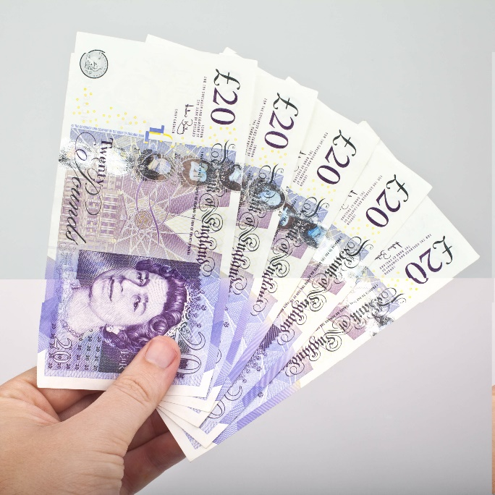

Cash Prizes

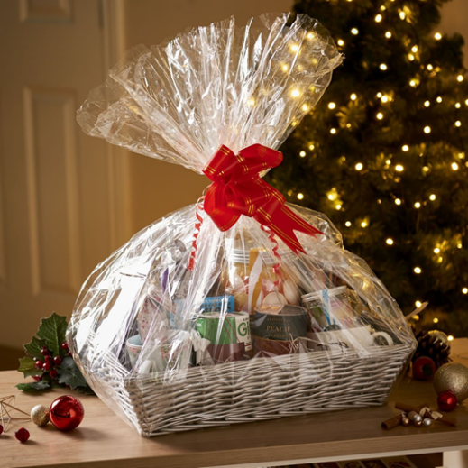

St. Oliver Plunkett P.S.
Christmas Draw

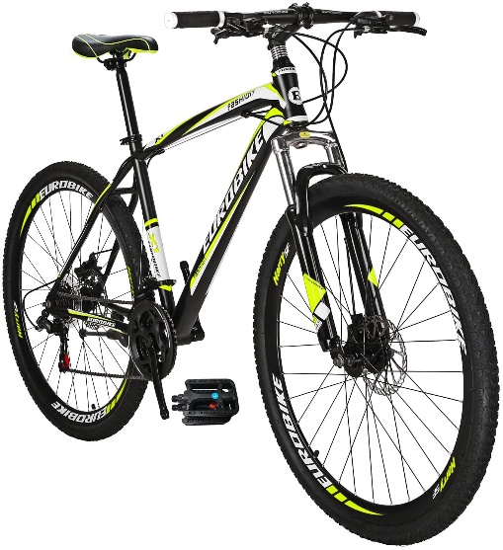
Tickets are now on sale for our Christmas Draw. We have a huge range of fantastic prizes this year, including an Oculus Quest 2 VR set’ brand new bike, a luxury hamper, cash, toys, vouchers… In fact, there are just too many to mention. You can enter as many times as you like.
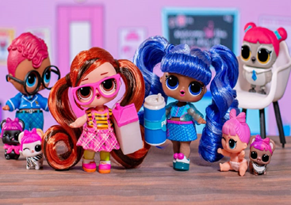

Remember, if you’re not in, you can’t win!

